D2L - Student Information
Official URL: https://services.smsu.edu/TDClient/180/Portal/KB/Article/2505/D2L-Student-Information
Category: Knowledge Base > Information Technology Services > Teaching and Learning (COLT) > D2L - Student Information
Tags: students, d2l, login
_____________________________________________________

Overview
D2L Brightspace is Southwest Minnesota State University’s online portal for classes that allows students to stay connected with their coursework 24/7. D2L is utilized by undergraduate, graduate, and online students. For online and face-to-face courses, D2L Brightspace is used to deliver content and supplemental materials. D2LBrightspace also includes tools for discussions, announcements, assignments, quizzes, and grades.
To access your D2L Brightspace, you will need to visit the D2L LOGIN PAGE and sign in with your StarID and password. If you cannot remember your password, hit the Forgot Your Password link on D2L Brightspace log in page. This will take you to the StarID Self Service page where you can retrieve your username or password. You will not be able to change your password when you login to your D2L Brightspace account.
If you are taking a class, but the class does not show up in D2L Brightspace, please speak to your professor first. Ask them to make sure that you are recognized on their class list under D2L Brightspace. If they say that you are listed and everything should work fine, but you are still unable to access that class’s page or are experiencing other problems, please contact the TRC Helpdesk.
If you have been accepted to SMSU and registered for classes, the system will automatically create a D2L account and enroll you in the course in D2L. Also, not every class uses D2L Brightspace. So you may find the class on D2L Brightspace, but there will be nothing on the Contents or Home pages.
SMSU provides a free D2L Brightspace class for all students to train them on how to use D2L Brightspace efficiently. For further assistance on D2L Brightspace, please contact the TRC Helpdesk.

D2L Brightspace Pulse
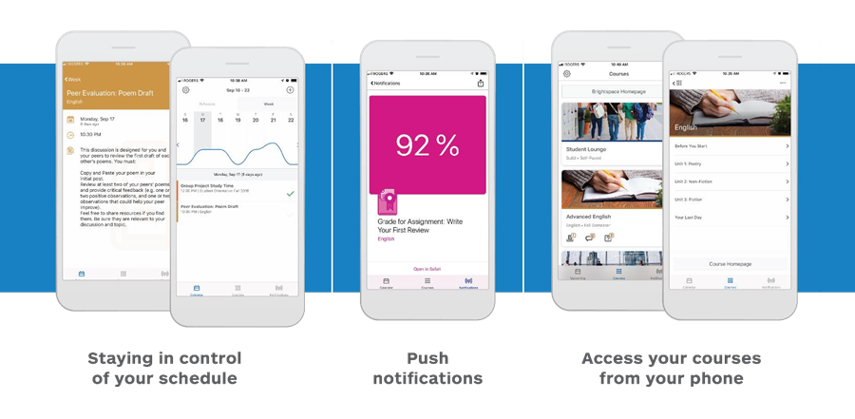
Figure 1: Screenshot
Stay connected and on track with your courses D2L Brightspace Pulse. The schedule view and weekly visualization provides a quick, at-a-glance view of what is due today, this week, and later in the term across all your courses. It provides one easy view of:
- Course calendars
- Readings
- Assignments
- Evaluations
- Grades
- Announcements
Brightspace Pulse is available for download from any global Google Play™ store or Apple App Store®. When you initially log in to Brightspace Pulse, you can quickly find your organization by turning on your device's geolocation service.
- From your device, tap the Brightspace Pulse icon.
- Learn more about Brightspace Pulse by swiping left/right or proceed to the next step by tapping Next.
- Tap Pick Your School.
- Enter your Brightspace Learning Environment credentials and then tap Log In.
D2L Brightspace Support for Students

Frequently Asked Questions (FAQ)
Why can't I log in to my D2L Brightspace account?
Make sure that your starid password has not expired. Resetting your Star ID password will fix most log in issues.
How do I sign up for notifications in D2L Brightspace?
It is recommended that you sign up for notifications so you can always be organized and up to dates on classes, assignments, quizzes etc.
What devices can I use to access D2L Brightspace?
To access D2L Brightspace you can use almost any type of device.
I am unable to see my enrolled semester courses in D2L Brightspace.
Firstly, assure you are officially registered. Note: it takes up to about 15 minutes for courses to appear in your account after you are officially registered. A quick guide on how to pin your semester courses. If you still can locate some of your course/s, log into your E-Services account and make sure that you are still enrolled in the class/es. If you are still enrolled in the class/es, then call or e-mail the Technology Resource Center Helpdesk.
Why can't I upload an Assignments file to D2L Brightspace?
First, check the Assignments Start and End date, if you are trying to submit a file outside of these dates you need to contact your instructor.
The other most common issue with file upload errors is the file name or extension. Assure your file name avoids special characters. Assure your file extension is displayed, for example:
• filename.pdf
• filename.docx
Special characters to avoid in file titles:
• Slashes ("/")
• Ampersands ("&")
• Colons (":")
• Question marks ("?")
• Quotation marks ("''")
• Pound signs or hashtags ("#")
• Asterisks ("*")
Accessibility Review & Update Log:
- [ ] Content accuracy verified
- [ ] Color contrast checked
- [x] Image alt-text verified (screenshots auto-captioned)
- [x] Document structure and headings formatted (perfect bold, list bulletpoints and sequences preserved)

